Safety and Security:
The institution provides a safety and security awareness and about environment to the students and
Staff of different genders, with the cooperation of institute security personnel, town police, fire
Department, local communities; it also provides awareness about medical and ambulance services
availability and utility.
The institute has fire extinguishers at appropriate places in each floor to address the fire incidences and First-aid boxes are kept available in all the departments, labs, security office, and administrative office. It has a medical room which is utilized for medical emergencies by staff and students.

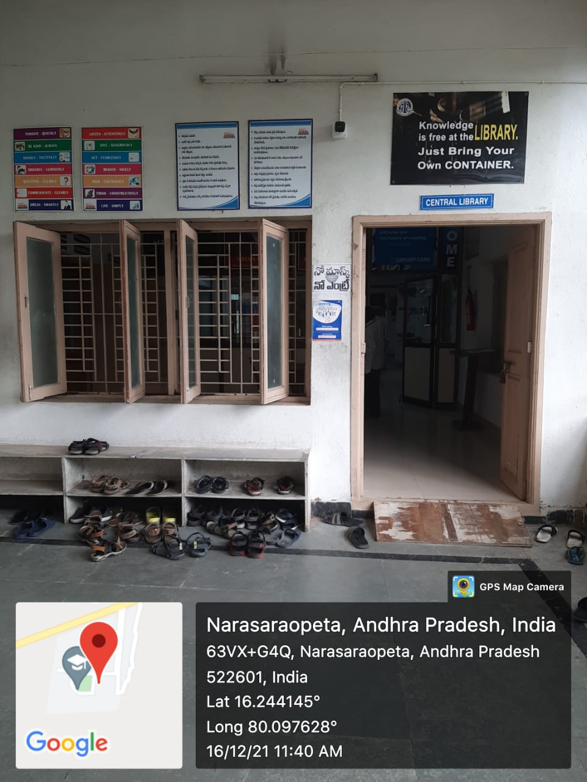
CC
CC
CC-Camera at central library, ground floor

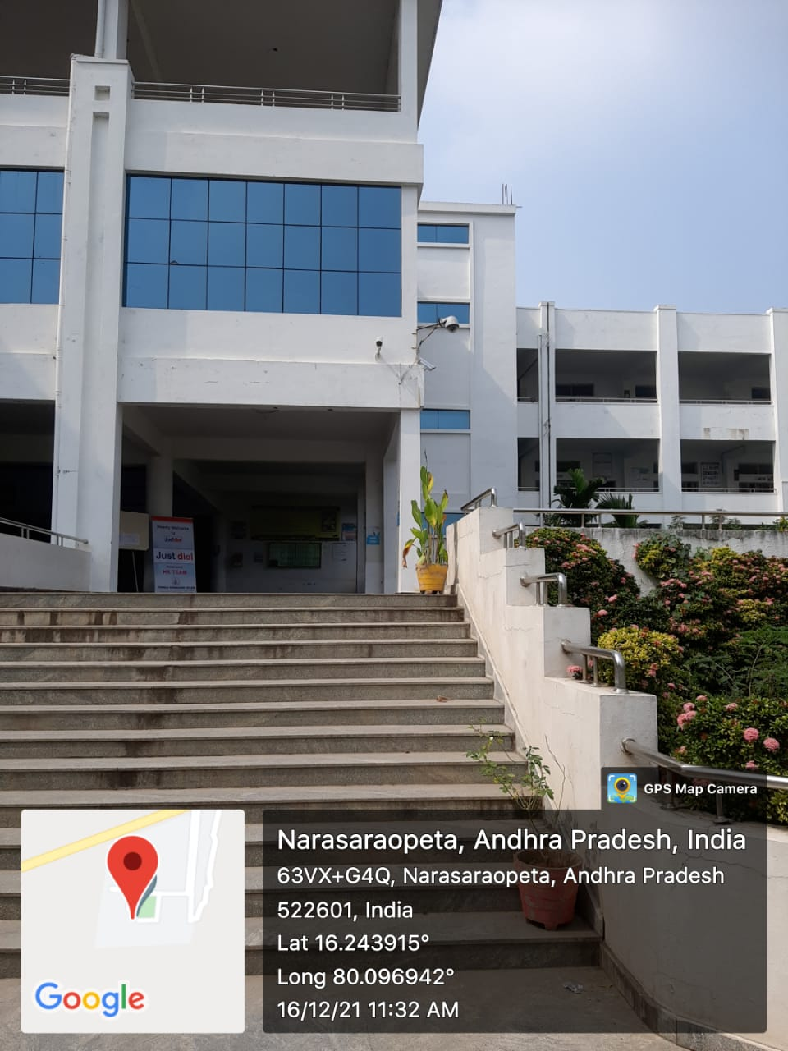
CC-Camera at Entrance, main block

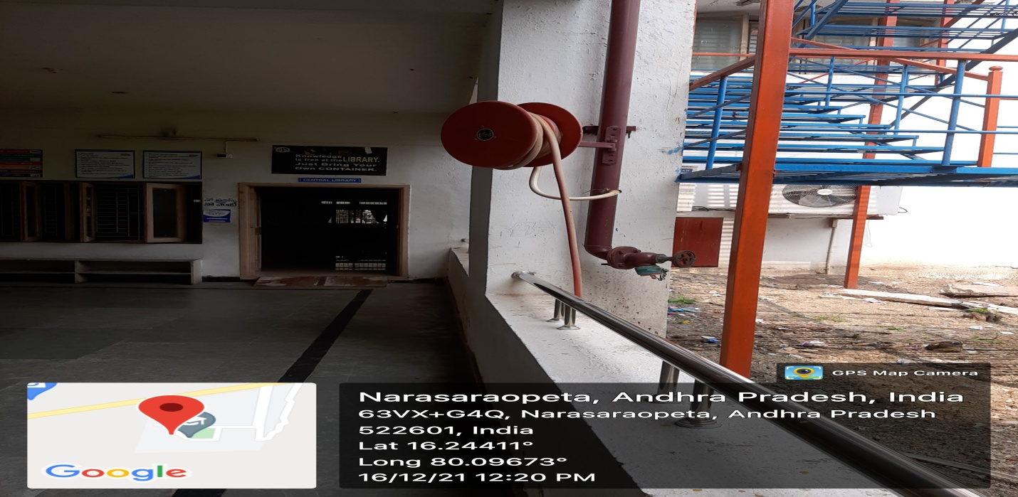

fire extinguishers at Ground floor

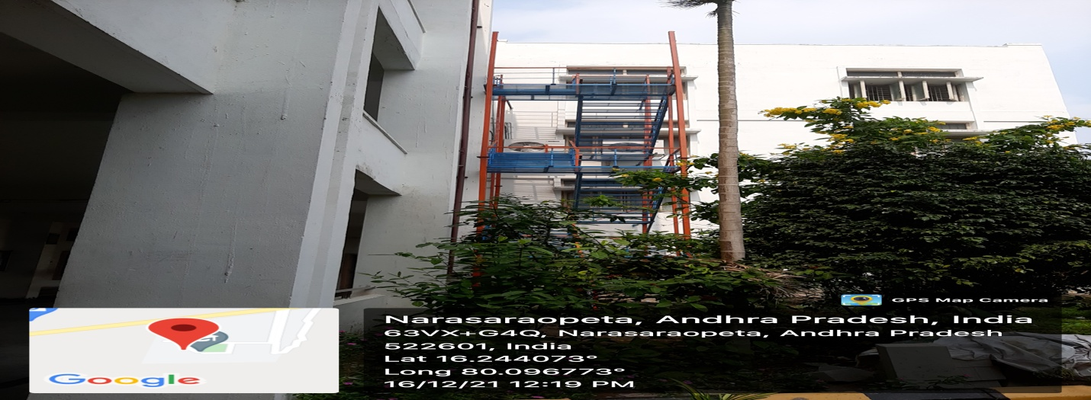
Emergency Iron steps at Ground floor

Counseling:
The institute provides counseling to the students for taking preventive steps with regard to academic
and non-academic related issues along with gender discrimination and sexual harassment.
It provides mentoring and counseling to the students on concurrent basis to make them aware of:
- Good academic performance
- Anti-Ragging
- Discipline and hard work
- Maintaining 100% attendance
- Wearing formal shoes in labs
- Use of aprons in labs for safety purpose.
- Safety parameters for riding two wheelers
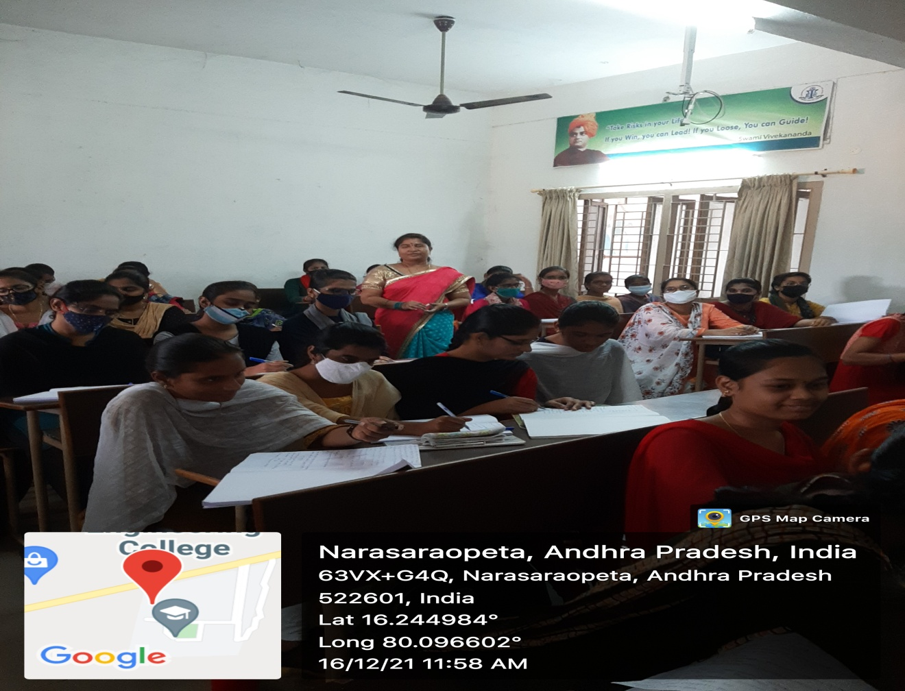
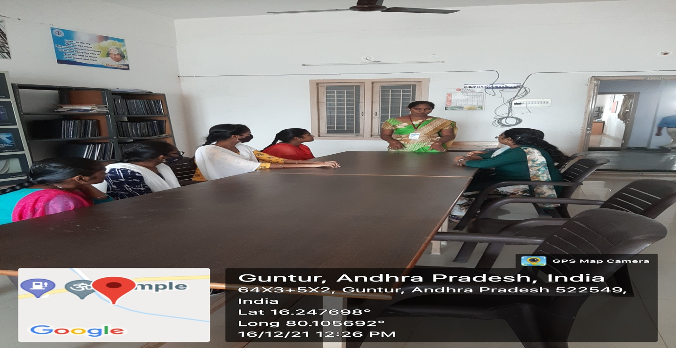
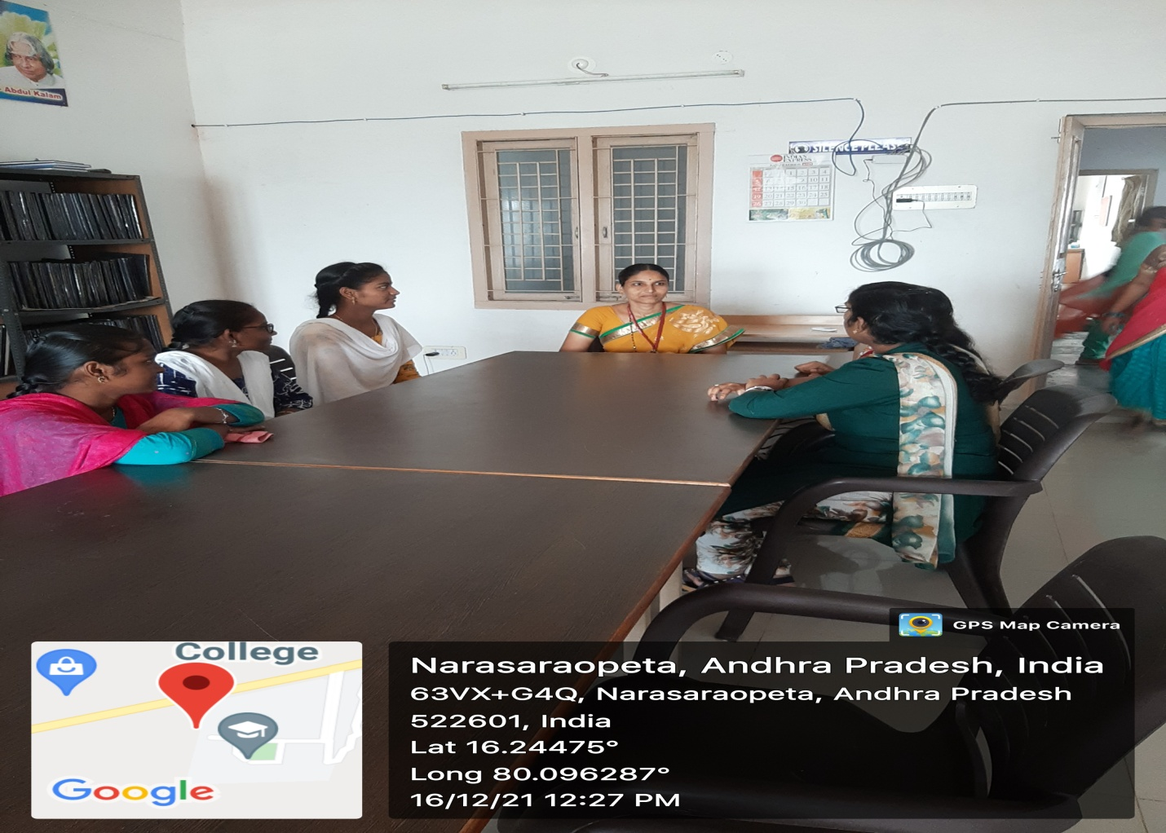
Students counseling

Common Rooms:
The institution provides common rooms for girls and boys for their relaxation and recreation which is
under security surveillance. Separate washrooms are provided to girls and boys.
Sanitary Napkin, first aid kit is available in rest room for girls.

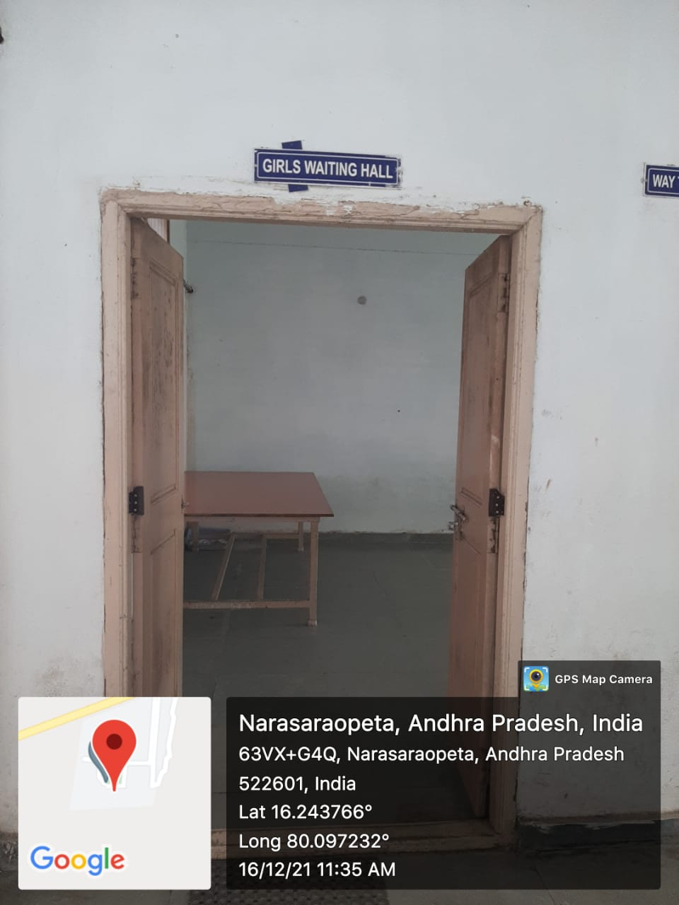

Women Waiting Room at Second Floor, main building

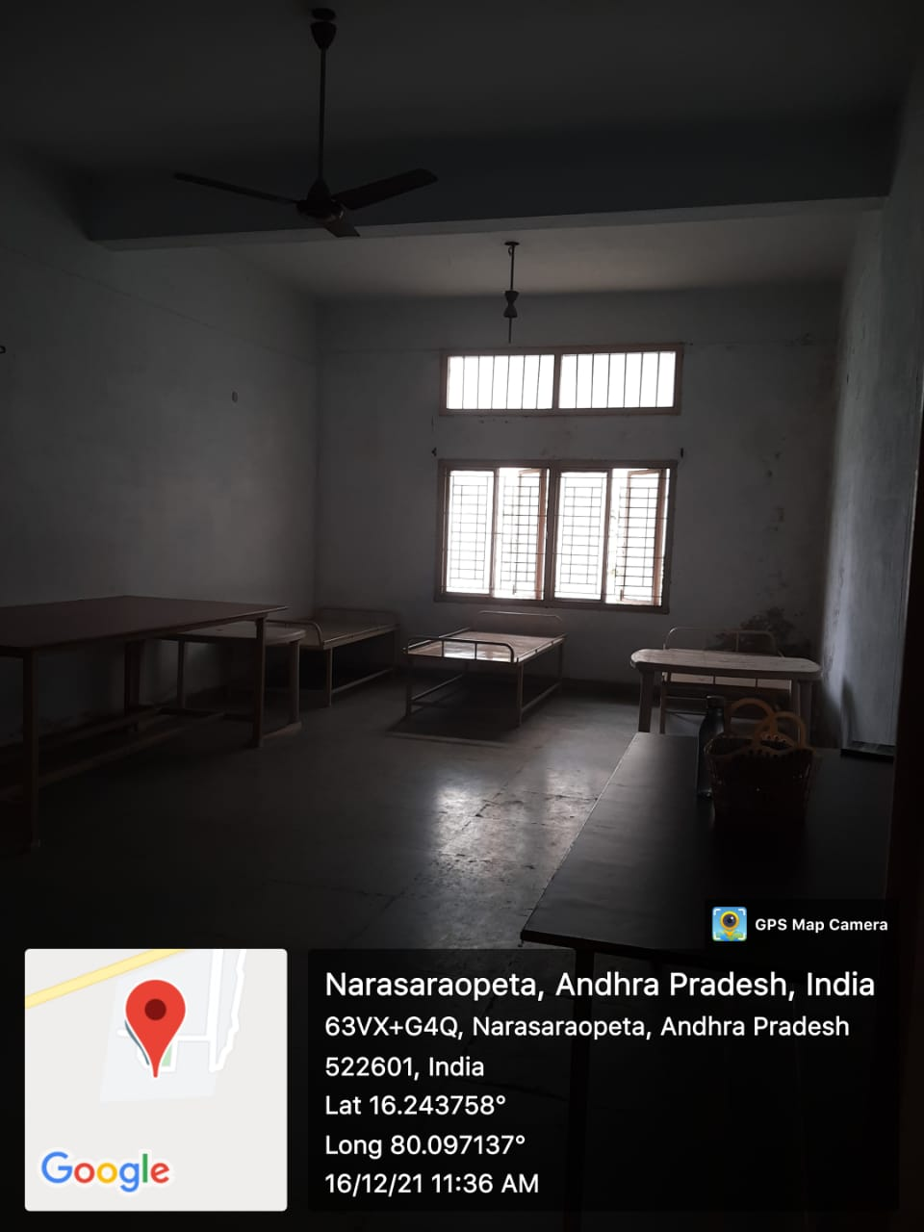

Beds in Women waiting Room 3rd floor, main building

